Process Name: MI Compilation

Client: Absa Bank

**USER MANUAL**

Table of Contents

1. Process Definition. 3

Process workflow. 3

Process steps by steps. 3

2. Errors, Exceptions and Solutions. 4

Error 1: 4

Solution Error 1: 4

Error 2: 4

Solution Error 2: 4

Exception 1: 4

Solution 1: 4

3. Identify Errors 4

4. Launching Application. 6

Launch the application. 6

How to run the process. 6

5. Important Guidelines. 8

# Process Definition.

## Process workflow.

Bot will copy; 100% Provisioned List-MMMYY-FROM CENTRE, MU_IFRS9_WD3_template MMM'YY, i9_mauritius_File Formatting Template-MMMYY, DRU Impairment for MMMYY Workings, MU_MMMYY-Acct-level Impairment WORKINGS , Group Fx Rate-DEC

the full record. Filter for the current date and take reference.

Folder YYYYMM folder for current month will be created in MI folder

Clear data in sheet; 1) DRU Imp (Bkt 2&3) Bal NOV19, 2) DRU Imp (Bkt4) Bal NOV19, 3) DRU FCY-Def Bkt-NOV19, 4) DRU CONSO2,3,4 Excl Nil NPV&GSD, 5) Impairment Summary DEC19, 6) Impairment WD3 DEC19, 7) Impairment Input DEC19, 8) 100%ProvOn+Offshre+FRAUD Nov19, 9) Centre Acct-level Imp-MU_Dec19,Group Fx Rate-DEC

Paste copied files to YYYYMM folder.

Add data in the sheet 1) DRU Imp (Bkt 2&3) Bal NOV19, 2) DRU Imp (Bkt4) Bal NOV19, 3) DRU FCY-Def Bkt-NOV19, 4) DRU CONSO2,3,4 Excl Nil NPV&GSD, 5) Impairment Summary DEC19, 6) Impairment WD3 DEC19, 7) Impairment Input DEC19, 8) 100%ProvOn+Offshre+FRAUD Nov19, 9) Centre Acct-level Imp-MU_Dec19, 10) Group Fx Rate-DEC

From file MU_Dec19-Acct-level Impairment WORKINGS, sheet i9 PVT update pivot table. If the difference obtained in cell exposure and Impairment is > 500000 then highlight the cell in Red.

From file MU_Dec19-Acct-level Impairment WORKINGS, sheet Impairment Rates, Pivot check, NPL Pivot and Stagewise PVT update all pivot tables.

## Process steps by steps.

1. Bot will create a folder MMYYYY for the compilation of MI for the current month in the Retail Credit – Compilation of MI folder.
2. Bot to Copy the **100% Provisioned List-MMMYY-FROM CENTRE**(current month – 1), **MU_IFRS9_WD3_template MMM'YY**(current month – 1), **i9_mauritius_File Formating Template-MMMYY**(current month – 1), **DRU Impairment for MMMYY Workings**(current month – 2), **MU_MMMYY-Acct-level Impairment WORKINGS**(current month – 1), to MI folder for the month.
3. In the following sheet; 1) **DRU Imp (Bkt 2&3) Bal NOV19**, 2) **DRU Imp (Bkt4) Bal NOV19**, 3) **DRU FCY-Def Bkt-NOV19**, 4) **DRU CONSO2,3,4 Excl Nil NPV&GSD,** 5) **Impairment Summary DEC19**, 6) **Impairment WD3 DEC19**, 7) **Impairment Input DEC19,** 8) **100%ProvOn+Offshre+FRAUD Nov19,** 9) **Centre Acct-level Imp-MU_Dec19,** 10) **Group Fx Rate-Dec19** ; bot to remove all data from cells.
4. Add data in sheet **DRU FCY-Def Bkt-NOV19,** sheet **DRU Imp (Bkt4) Bal,** **DRU Imp (Bkt 2&3) Bal NOV19** sheet, sheet **DRU CONSO2,3,4 Excl Nil NPV&GSD.**
5. **In sheet DRU CONSO2,3,4 Excl Nil NPV&GSD** delete all rows where Column NPV is 0 or Error.
6. Clear sheet **Group Fx Rate-MMMYY**(file MU_workings). Then from sheet **Group Fx Rate-MMMYY** (file i9 mauritius) copy data and paste in sheet **Group Fx Rate-MMMYY**(file MU_workings).
7. Verify if sheet **PVT**(file i9 mauritius) cell **F19(Exposure Diff WD3 vs i9)** and sheet **Pivot check**(file MU_workings) cell **K37** is matched else highlight cell K37 sheet **Pivot check**(file MU_workings) in red.
8. Verify if sheet **Pivot check**(file MU_workings) cell **K34** and cell **N34** is **> than 50 000 or < -50 000** highlight the cell in orange and display comment box with the given message, **“Kindly investigate the difference”.**
9. Delete all where the local balance (revised) and Exp_Loss_End_Rep_Per_Local are zero or Error (**sheet 19_mauritius_DEC19**)
10. Add data in sheet **Impairment Summary Dec19**, **Impairment WD3 DEC19** sheet, **sheet Impairment Input Dec 19**, sheet **100%ProvOn+Offshre+FRAUD Dec19**, sheet **Centre Acct-level Imp-MU_Dec19**.
11. From file **MU_Dec19-Acct-level Impairment WORKINGS,** sheet **i9 PVT** update pivot table. If the difference obtained in cell exposure and Impairment is > 500000 then highlight the cell in Red.
12. From file **MU_Dec19-Acct-level Impairment WORKINGS,** sheet **i9PVT,** sheet **Impairment Rates,** sheet **NPL Pivot,** sheet **Stagewise PVT** update all pivot table.

# Errors, Exceptions and Solutions.

## Error 1:

System not able to launch and login.

### Solution Error 1:

Restart the process, as the system may be delayed during the launching process.

## Error 2:

If structure or data in file are different, the process won’t run.

### Solution Error 2:

Verify that the file structure has not been modified.

## Error 3:

If Sheet name are different, the process won’t run.

### Solution Error 3:

Verify that the sheet name is well written.

## Error 4:

If hidden rows or columns are present/ or filtered columns are present, the process won’t give the expected output result.

### Solution Error 4:

Ensure that no hidden rows or columns are present and sheets are unfiltered.

## Exception 1:

If files are already present in output folder ‘MMYYYY’, the bot will consider the process to have already be run and will display popup message ‘Completed’.

### Solution 1:

Make sure all files in output folder ‘MMYYYY’ are deleted before running the process to get updated data.

## Exception 2:

Note that the process is running for the following files;

1. 100% Provisioned List-MMMYY-FROM CENTRE.xlsx
2. DRU Impairment for MMMYY Workings.xls
3. MU_MMMYY-Acct-level Impairment WORKINGS.xlsx
4. MU_IFRS9_WD3_template MMM'YY.xlsb
5. i9_mauritius_File Formating Template-MMMYY.xlsx

However, the bot will be able to run the process by finding a specific name from the file name;

1. **100%** Provisioned List-MMMYY-FROM CENTRE.xlsx

* If **100%** is found in the file name the process will run.

1. **DRU** Impairment for MMMYY Workings.xls

* If **DRU** is found in the file name the process will run.

1. MU_MMMYY-**Acct**-**level** Impairment WORKINGS.xlsx

* If either **Acct** or **level** is found in the file name the process will run.

1. MU_**IFRS9**_WD3_template MMM'YY.xlsb

* If **IFRS9** is found in the file name the process will run.

1. **i9**_mauritius_File Formating Template-MMMYY.xlsx

* If **i9** is found in the file name the process will run.

### Solution 2:

Make sure the files name contains the following;

* **100%**
* **DRU**
* either **Acct** or **level**
* **IFRS9**
* **i9**

# Identify Errors

How to Identify if Bot Fail?

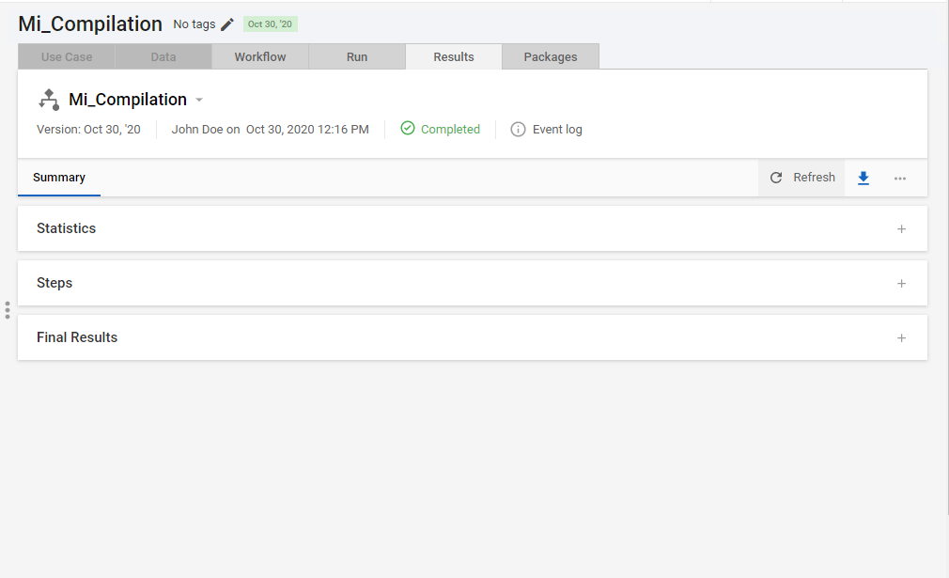

1. If a Red Coloured Mark is found in Results Tab, the bot has Failed(e.g if the event log icon is in red).
2. Click on Event Log to check more logs.

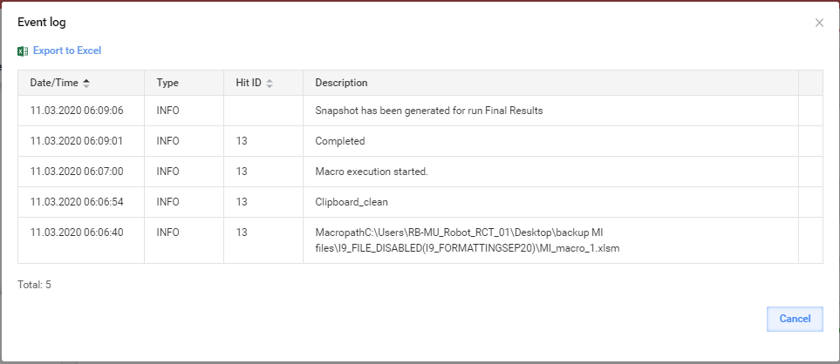

1. Check the Type ERROR to find more details, will get an idea why the BOT has Failed.

# Launching Application.

## Launch the application.

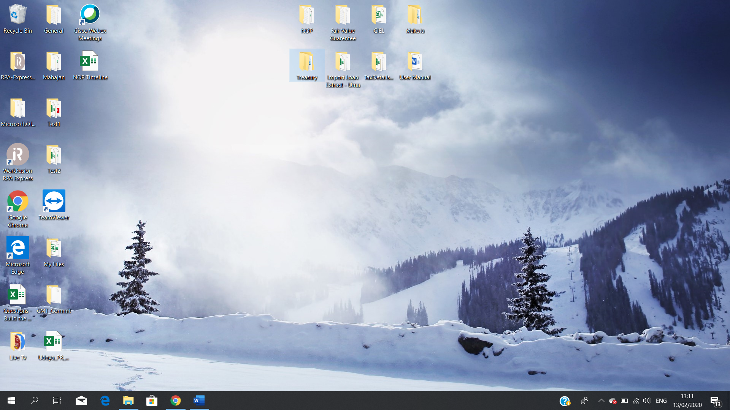

Double Click on the Work Fusion RPA Express icon.

## How to run the process.

1. Place All the excel files in MI files folder (exception: don’t move MU_Acct-level Impairment working template as it is placed in MU_workings – TEMPLATE folder)

(Path of input files🡪\\Muebcyp02fvg02\rct$\Absa\Corporate Entity\Year YYYY\IMPAIRMENT\7. WD3\MM. MmmYYYY\Workings\Account level Impairment\NANO BANK-EOM MmmYYYY Data\)

1. Open Work Fusion Studio selecting the Work Fusion Icon.

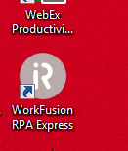

*If a prompt window appears asking for secured password. Enter password “****admin****”.*

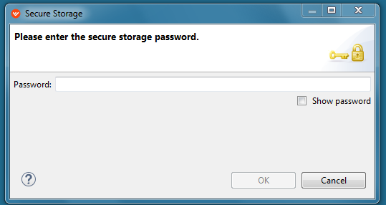

1. Start the Server by turning ON slide button present in Components tab.

* Before server start:

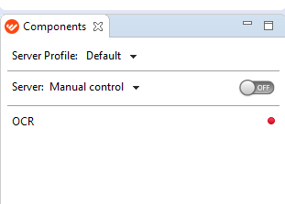

* After server start, the slide button will turn into yellow. Then select **Control Tower** link to open the server log in page in the browser.

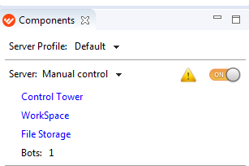

* Please wait at least 10 minutes after starting the server for better performance.
* All ways keep the server in Manual control.

1. The Control Tower should open within a browser. If it is not the case then click on this link: [Control Tower](http://localhost:15280/workfusion/login)

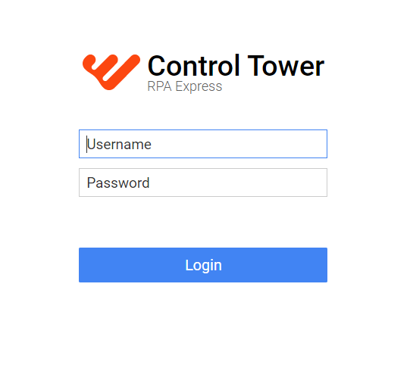

1. Use below login Credentials

User Name: **admin**

Password: **Barclays**

1. Click on ‘Business Processes’. All the business processes will be shown as a list.

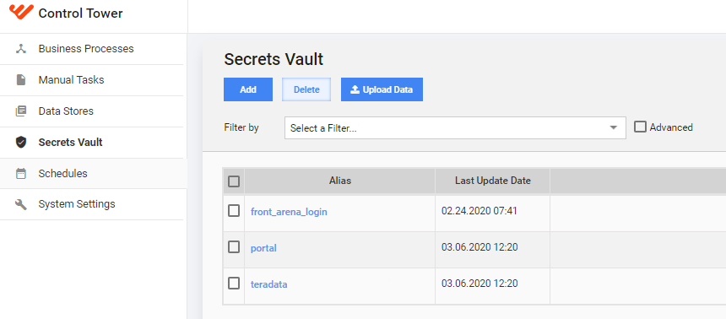

1. Double click on the Bot Process name.

Process Name: **Mi_Compilation**

1. The business process display will expand and details of the execution will be shown if it was already run before. From the first link of detail that appear click on the option button found on the right (3 dots).

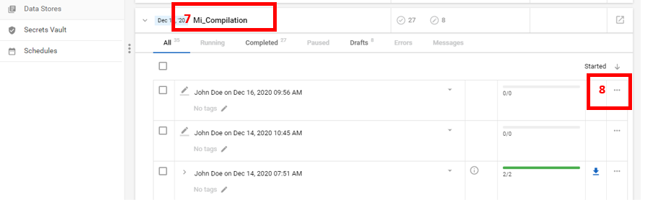

1. Then click on **Copy.** A window will appear.
2. 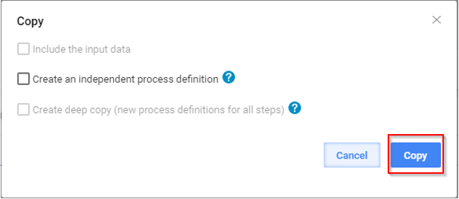Click on **Copy** to make a copy of the business process.
3. 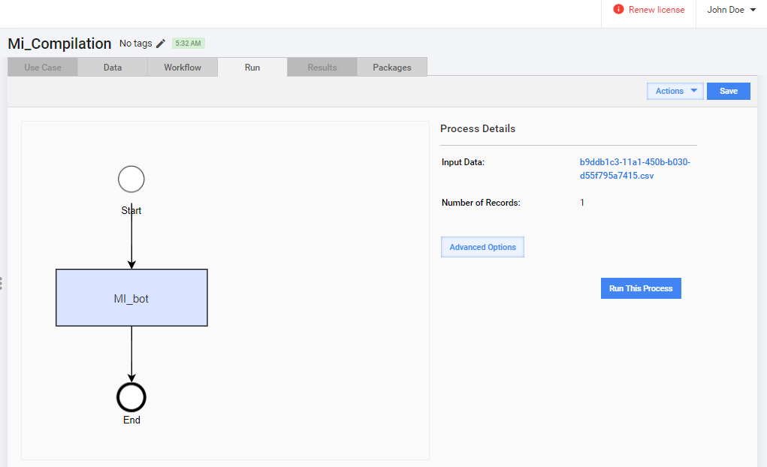From **Run** tab and click on **Run this Process** button.
4. Click on **View Results** button to view BOT running condition.



1. The macro file will start processing. From the beginning of the process a prompt form will appear asking to enter the **month** in format **MM**. If the process is being run for the month of April then enter **04.** And click on **OK** button.

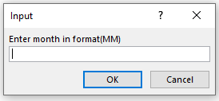

If the format is not good, the prompt form for month will still appear until the good format is inserted.

1. 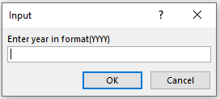Another prompt form will appear asking to enter the **year** in format **YYYY** and click on **OK** button.

If the number of digits for year does not contain 4 digits(E.g 2020), the prompt form for year will continue to appear until the good format is inserted.

1. When the month and year has been correctly inserted, the process will continue to run to the end of the process by display a message box with the header name “**Completed**”.

# Important Guidelines

* Make sure the valid information is followed as in the Instructions (see the icon ).
* When process is running, make sure no one is using the laptop or doing any movement with the mouse.
* When Process is running don’t open the Input Instructions.